Reduction of TDS in waste water by using Potash Alum

### A PROJECT REPORT SUBMITTED IN PARTIAL FULFILLMENT OF THE REQUIREMENTS FOR THE DEGREE OF

### Master of Science

### In

### Chemistry By

**Mr. SIDDHARTH PANDYA**

### Under the guiadance of

### Dr. Tirth Thaker



# DEPARTMENT OF CHEMISTRY

# PARUL INSTITUTE OF APPLIED SCIENCE

## LIMDA-391760, VADODARA, GUJARAT,INDIA

### Declaration

I, **Mr. SIDDHARTH PANDYA,** of Parul Institute of Applied science, Parul University, Vadodara hereby undertake that the work presented in the dissertation project report entitled **"** **Reduction of TDS in waste water by using Potash Alum”** comprises the results of independent and original work carried out by me under the supervision of **Dr.Tirth Thaker,** Assistant Professor, chemistry.

I further declare that this work did not form a part of any other work published or unpublished.

**SIDDHARTH PANDYA**

Date

Place: Vadodara



# PARUL UNIVERSITY

## CERTIFICATE

Enrollment No:191127205038

Date: / /2021

This is to certify that the work recorded in this dissertation report entitled as “Reduction of TDS in waste water by using Potash Alum” is the actual work of Mr. SIDDHARTH PANDYAof the **Master of Science** in **Chemistry** during the fourth semester of academic year 2020-2021.

**Guided By: Head Principal & I/C Dean**

**Dr. Tirth Thaker Dr. Ageetha Vanaamudan Mr. Trilok Akhani**

Department of Chemistry Department of Chemistry PIAS

PIAS PIAS Parul University

Parul University Parul University

# Acknowledgement

I would like to express my gratitude to my supervisor **Dr. Tirth Thaker**, Assistant Professor, Department of chemistry. I would like to express my gratitude and sincere appreciation for his guidance, valuable care,, supervision, encouragement and kindness towards me throughout this study.

I convey my special acknowledgement to **Parul University**, for providing all essential facility required for the dissertation work as well as to complete the M.Sc. course.

I also take this opportunity to give my thank note to **Dr. Ageetha Vanaamudan** for nice timely support.

I offer thanks to **Mr. Trilok Akhani,** Principal of Parul institute of applied science for providing necessary infrastructure.

I would like to thank my friend **Mr. DARSHAK HADIYA** for her timely co-operation in my dissertation work as well as M.Sc. tenure.

I am also thankful to my lab mates **RAJDEEPSINH PARMAR, KRUPA PATEL, SACHIN VALAND, AKANSHA, VIVEK HUDKA** for their cheerful cooperation during entire tenure.

I express my deep sense of gratitude to my beloved parents whose constant encouragement and trust gave me invisible power to cope up not only during whole M.Sc. Course tenure but through out my life.

**SIDDHARTH PANDYA**

**Index**

|  |  |  |
| --- | --- | --- |
| **Sr. No.** | **Content** | **Page Nos.** |
| **1.** | **Abstract** | **1** |
| **2.** | **Introduction** | **2** |
| **3.** | **Materials and Method** | **11** |
| **4.** | **Results and Conclusion** | **17** |
| **5.** | **References** | **18** |

**List of Figures**

|  |  |  |
| --- | --- | --- |
| **Fig: 1** | **Air pollution by industries** | **2** |
| **Fig: 2** | **Air and Land pollution due to forest fire.** | **3** |
| **Fig: 3** | **Turbidity level in increasing order (Left to Right)** | **9** |
| **Fig: 4** | **Collected Sample From Industry** | **11** |
| **Fig: 5** | **Distillation setup** | **12** |
| **Fig: 6** | **Crushing Potash alum** | **14** |
| **Fig: 7** | **Distillation of sample** | **15** |

Reduction of TDS in waste water by using Potash Alum

**1. ABSTRACT**

Potash alum is double salt commonly known as common alum. This is commonly used for purification of drinking water. During rainy season the water bodies become turbid and contaminated. To purify this water potash alum is used without knowing much about concentration of its use. In the present investigation, the idea is to use Potash alum in waste water and analyse the data. The analysis of Waste water quality is made with respect to its TDS, TSS, TURBIDITY.

**2. Introduction**

**Pollution :** Also referred to as environmental pollution, the addition of any substance solid, liquid, or gas or any style of energy like heat, sound, or emission to the atmosphere at a rate quicker than it are often distributed, diluted, decomposed, recycled, or hold on in some harmless type. the most important types of pollution, sometimes classified by atmosphere, are air, water, and land pollution.

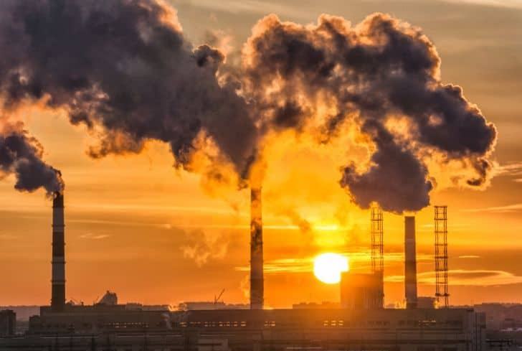

**Fig. 1 Air pollution by industries**

# Biodegradable pollutants decompose rapidly processes and non biodegradable pollutants do not decompose slowly in the environment. Environment is defined as the sum of total of all living and non-living around us influencing one other. Degradation of the environment has become a serious problem. Pollution of soil, water and air leads to loss of valuable natural resources. 1

**History of Pollution**

Although environmental pollution are often caused by natural events like forest fires and active volcanoes, use of the word pollution typically implies that the contaminants have source—that is, a supply created by human activities. Pollution has attended human race ever since teams of individuals initial congregated and remained for an extended time in anyone place. Pollution wasn't a significant drawback as long as there was enough area accessible for every individual or cluster. However, with the institution of permanent settlements by great numbers of individuals, pollution became a retardant, and it's remained one ever since.

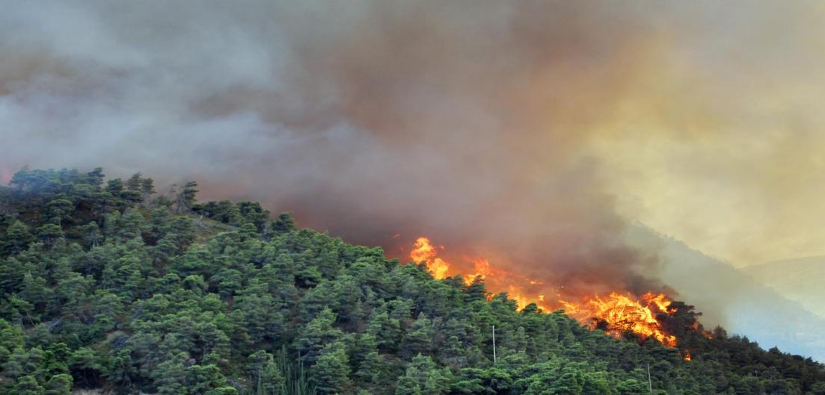

**Fig. 2 Air and Land pollution due to forest fire.**

**Water Pollution**

Water is an indispensable natural resource essential for the existence of man and the ecological system. Though water is abundantly available in the universe, only 3% of it is fresh water. Approximately, 5% of the fresh water, equivalent to 0.15% of the entire global waters is readily accessible for beneficial purposes 2.Water Pollution can be defined as presence of solid, liquid or gaseous contaminants in such concentration that may alter the quality of water and affects the life of living organisms. Industrial wastewater released into the water bodies is one of major sources of environmental pollution 3. Food processing industries are one of the major sectors which consume a huge amount of water for their production process, Such industries consist of different kinds of production like dairy products, beverages, vegetables and fruits, and meat 4. Wastewaters produced by food processing industries do not have high amount of toxic pollutants, however, they are high in concentrations of organics loading, BOD, and TDS5. One study examined the quality of receiving soil and water for discharged food processing wastewater in Nigeria showing there is a necessity for treatment prior to discharge since wide range of pollutants can damage the environment significantly6.

The discharge of wastes into the water bodies by man had brought about modification of the environmental water quality, hence making substantial quantities of water unsuitable for various uses 7. Compromise in the quality of the environment as a result of effluent discharge from the industrial sectors has become an environmental issue for many countries especially developing nations like Nigeria 8

**Other Cause of Water Pollution**

* Domestic Waste
* Solid Waste
* Industrial Waste Water
* Radioactive Waste

**Due to waste water there is a huge change in the properties of water like**

* Total Dissolved Solids
* Total Suspended Solids
* Determination of pH
* Determination of chloride content
* Determination of sulphate content
* Iron content
* Manganese content
* Turbidity
* BOD
* COD

BOD and COD often give indications of the extent of organic pollution in water and wastewater 9. BOD/COD ratio of wastewater is referred to as the biodegradability index, usually used to estimate the likelihood of organic components degradation in wastewater prior to treatment. Wastewater with BOD/COD value greater than 0.6 is considered fairly biodegradable and could be effectively treated biologically 10.

**What is TDS?**

Total Dissolved Solids in water are measures of organic, inorganic or salts that are dissolved in a particular quantity in water11. The solids should be small enough to survive filtration through a filter which has two-micrometer (nominal size or smaller) pores.

We generally discuss TDS for freshwater systems only, as salinity consists of some of the ions contributing in the definition of TDS. The Study of water quality for streams, rivers and lakes is the most important application of TDS, although TDS is not a primary pollutant, but TDS is used as an indication of aesthetic characteristics of drinking water and as an indicator of the presence of a broad array of chemical contaminants. Calcium, phosphates, nitrates, sodium, potassium, sulphates and chloride comprise few of the important chemical constituents. Pesticides arising from surface runoff are more exotic and harmful elements of TDS. Certain naturally occurring total dissolved solids arise from the weathering and dissolution of rocks and soils.

A significant growth has occurred in the industries of developing countries in the recent years. These industries discharge wastewaters which carry high concentrations of dissolved solids and biochemical oxygen demand (BOD). These effluents should be treated for safe disposals which meets the regulations imposed on industrial sectors. Industrial wastewaters have high concentrations of total dissolved solids.12 Textile industry is one of the most important and rapidly developing industrial sectors. India has a large network of textile industries of varying capacity i.e. about 10,000 garment manufacturing and 2,100 bleaching and dyeing industries.13 These are well developed and scattered all over the country with its main centers at Ahmedabad, Mumbai, Chennai, Coimbatore, Bangalore and Kanpur. Al-Kdasi and his colleagues reported that the textile wastewater is characterized mainly by high BOD (80-6,000 mg L-1), COD (150-12,000 mg L-1), suspended solids (15-8000 mg L-1), dissolved solids (2900-3100 mg L-1) and chloride (1000-1600 mg L-1).14 The inorganic chemicals hold a greater portion as contaminants in drinking water in comparison to organic chemicals.15 A part of inorganics are in mineral form of heavy metals. Heavy metals tend to accumulate in human organs and nervous system and interfere with their normal functions. In recent years, heavy metals such as lead (Pb), arsenic (As), magnesium (Mg), nickel (Ni), copper (Cu), and zinc (Zn) have received significant attention due to causing health problems.16 Moreover, the cardiovascular diseases, kidney-related problems, neurocognitive diseases, and cancer are related to the traces ofmetals such as cadmium (Cd) and chromium (Cr) as reported in epidemiological studies 17. The Pb is known to delay the physical and mental growth in infants, while As and mercury (Hg) can cause serious poisoning with skin pathology and cancer and further damage to kidney and liver, respectively. 16, 18

TDS is a very important property of water which should be maintained in waste water in such a way that it should not affect the living organisms. For the maintaining such properties of water there are several methods used in industries like RO, Disstillation, Saw dust, etc.

One of its method is to treat the water with Potash alum which came out to be very effective in reducing Turbidity and TDS of waste water of industry and domestic use.

**Turbidity**

The haziness or cloudiness of a fluid due to various individual particles(TSS or TDS) that can be seen with naked eyes (like smoke in air) is known as turbidity. The determination of value of turbidity might be termed as one of the most important tests of water quality.

Fluids may have suspended solid matter comprising of particles of various different sizes. While some will be big enough settle down quickly at the bottom of the container if a liquid sample is left to stand, the smaller ones might settle very slowly or might not settle at all if the sample is agitated consistently or if the colloidal particles are present. These solid particles, which are smaller in size are the reason for any liquid to look like turbid.

Higher efficiency to treat turbid water has made inorganic chemicals favorite coagulants. Not only are they low priced but are also readily available. In

water, most of the particles are negative charged, to neutralize the charge a positive ion (cation) may be used as a coagulant. Potassium hydroxide contributes a mono-valent ion, K+. Calcium hydroxide gives a divalent ion, Ca2+. Aluminum coagulants give trivalent aluminum ions, Al3+.19

Turbidity(or haze) is considered in the case of transparent solids such as glass as well. In plastic production, the percentage of light that is deflected more than 2.5° from the incoming light direction is known as haze. Turbidity can also be termed as the measure of a liquid’s relative clarity. Turbidity is an optical characteristic of water and is also an expression of the amount of light scattered by material in the water when a light shines through the water sample. The higher the intensity of scattered 14 light, the higher the turbidity. Material causing water to be turbid include silt, clay, finely divided inorganic and organic matter, soluble colored organic compounds, algae, plankton and various other microscopic organisms.

Turbidity makes water cloudy or opaque. The water collected in the bottle is used to find out the turbidity, which is measured by shining a light through the water and is measured in nephelometric turbidity units (NTU). During periods of low flow (base flow), many rivers are a clear green color, and turbidities are low, usually less than 10 NTU11.

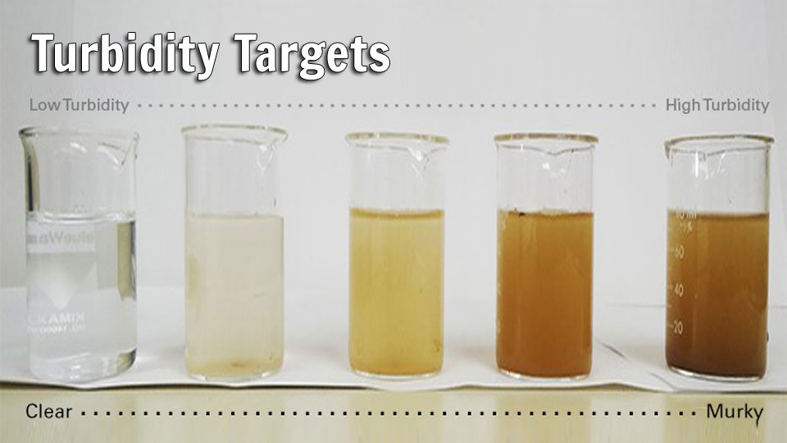

**Fig.3 Turbidity level in increasing order (Left to Right)**

Higher efficiency to treat turbid water has made inorganic chemicals favorite coagulants. Not only are they low priced but are also readily available 19. In water, most of the particles are negative charged, to neutralize the charge a positive ion (cation) may be used as a coagulant. Potassium hydroxide contributes a mono-valent ion, K+. Calcium hydroxide gives a divalent ion, Ca2+. Aluminum coagulants give trivalent aluminum ions, Al3+. According to Schultz in 1882 and Hardy in 1900, higher the charge of cation, more effective is charge neutralization. Alum is one of the most widely used coagulants in the water treatment industry 20. For water and wastewater treatment, the coagulants used more frequently are the inorganic salts of aluminum. When added to water, Al ions hydrolyze rapidly and form a range of metal hydrolysis species 21. These cationic species adsorb onto the negatively charged particles and neutralize the charge. In this mechanism, particles get destabilized and aggregation occurs 24.

Coagulation depends on coagulant dosage and also the ph. Almost all of the colloids in water are negatively charged and because of electrical repulsion they may remain stable. Destabilization could be made by addition of salts or cations that will interact with negative colloids to neutralize their charge 22. Water from floods and rain run offs is muddy and contains lot of turbidity. With the addition of coagulants, turbidity can be removed and thus clear water may be obtained. However, addition of inorganic coagulants to remove turbidity may lead to adverse impacts on human health 23 In the present study an attempt has been made to use Potash alum as a reagent for removal of pollutants and lowering TDS value so which can be dumped into water receiver body.

# 3. Materials and Method

**3.1 Sample Collection**

Two bottles of 500ml were collected from industry and its properties were checked like TDS, pH, Turbidity etc.

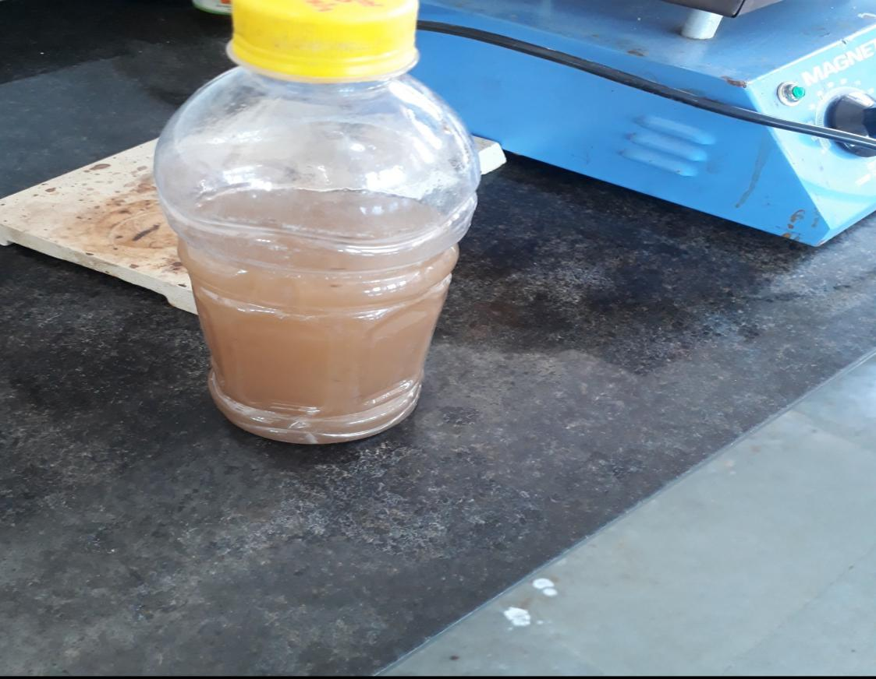

**Fig.4 Collected Sample From Harni Lake**

**3.2 Apparatus**

For the measurements of various properties of sample water we used following apparatus

* Condensor
* Reciever
* RBF
* Distillation setup
* Heating mental
* Beaker
* Funnel
* Filter paper
* Tripod
* Stand
* Tube
* Ph meter
* Potash Alum

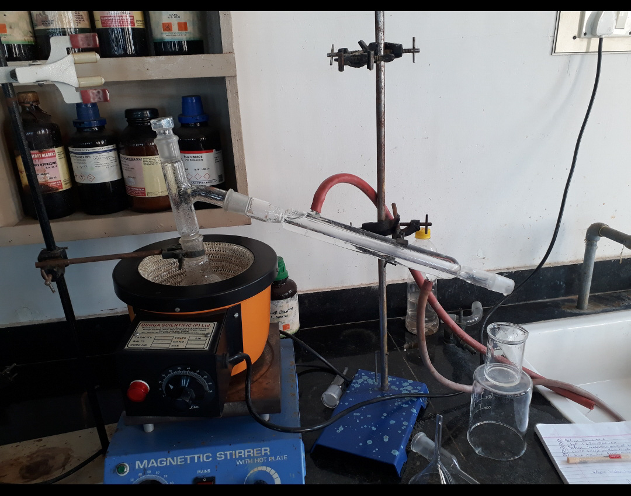

**Fig.5 Distillation setup**

**3.3 Procedure**

This experiment was carried out in three steps. The first step is to collect the sample and measures the parameters like Ph, TDS, Turbidity, Colour, etc.

Effluent 1: Taken from canal near PIAS

Effluent 2: Taken from Harni lake, Vadodara

In second step potash alum was added to reduce the Ph, TDS & Turbidity.

In third step this sample was filtered and water was kept in distillation unit for distillation.

**1st Stage**

First step is to collect sample from different industries in 500 ml bottle and potash alum.

|  |  |  |  |  |
| --- | --- | --- | --- | --- |
| **Sr. No.** | **Effluent 1** | | **Effluent 2** | |
| Parameters | Untreated Outlet Effluent | Parameters | Untreated Outlet Effluent |
| 1. | pH | 7.9 | pH | 8.3 |
| 2. | TDS ( mg \ l ) | 941 | TDS ( mg\l ) | 1043 |
| 3. | Color | Dark Brown | Color | Grey |

* **Table – 1 : Initial characteristic of outlet effluent :**

**2nd Stage**

Potash alum was crushed due to which its contact surface increases which helps it to settle down the minute particulates and decrease the turbidity of water.

Potash alum finely crushed and added to the effluent, then this effluent mixed or stirred and then it was put aside to settle down.

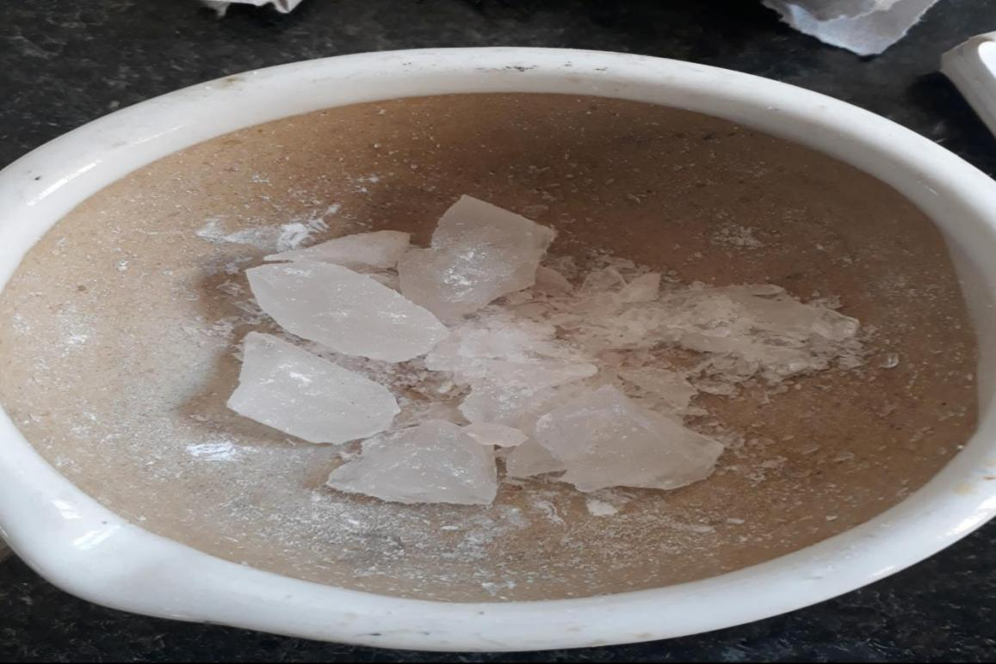

**Fig. 6 Crushing Potash alum**

* **Table - 2 : Characteristic of outlet effluent after treatment with potash alum :**

|  |  |  |  |  |
| --- | --- | --- | --- | --- |
| **Sr. No.** | **Effluent 1** | | **Effluent 2** | |
| Parameters | Treated Outlet Effluent | Parameters | Treated Outlet Effluent |
| 1. | pH | 7.3 | pH | 7.2 |
| 2. | TDS ( mg \ l ) | 650 | TDS (mg\l ) | 711 |
| 3. | Color | Light khaki | Color | Light cream |

**3rd Stage**

Distillation assembly was set up by joining condenser, reciecer, Double necked RBF flask, Heating mantle, beaker, filter paper, stand, etc.

The effluent was filtered after the settling down of the particulate and this effluent then transferred to the double necked RBF flask.

This flask setup in the distillation unit for distillation.

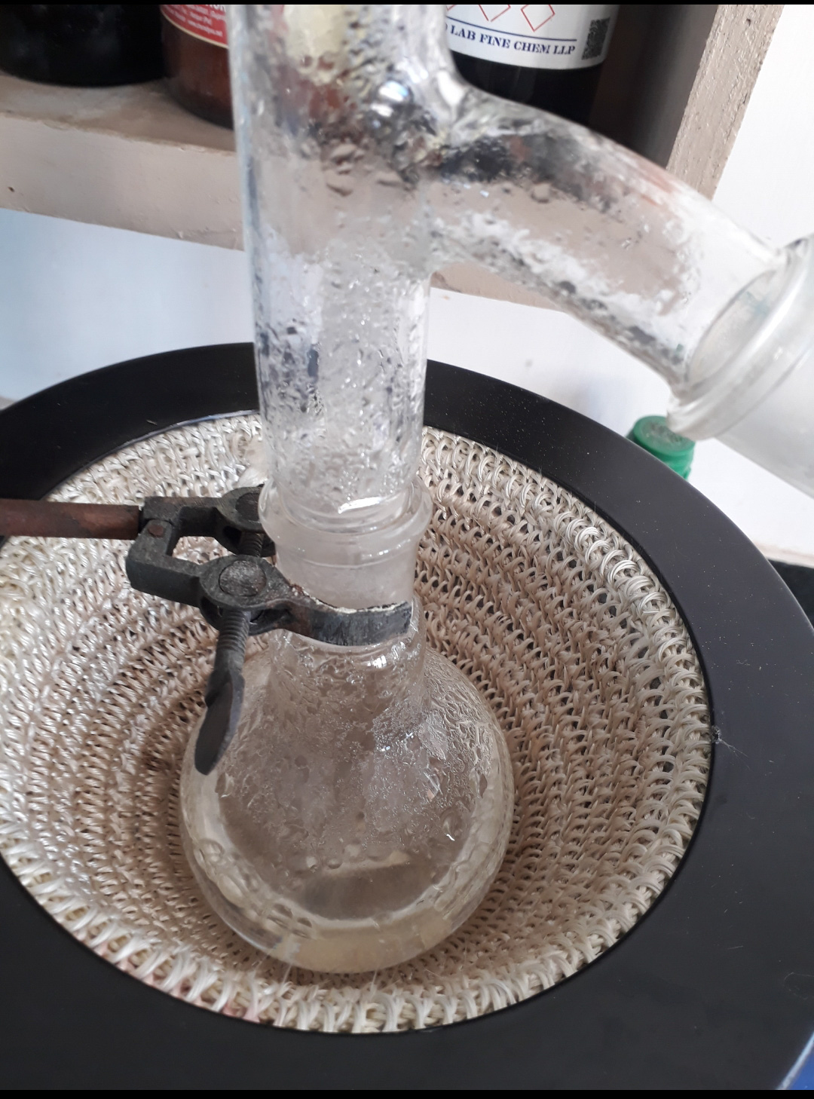

**Fig.7 Distillation of sample**

Then this sample examined further for its various parameters.

|  |  |  |  |  |
| --- | --- | --- | --- | --- |
| **Sr. No.** | **Effluent 1** | | **Effluent 2** | |
| Parameters | Treated Outlet Effluent | Parameters | Treated Outlet Effluent |
| 1. | pH | 7.2 | pH | 7.1 |
| 2. | TDS ( mg \ l ) | 371 | TDS (mg\l ) | 386 |
| 3. | Color | colorless | Color | colorless |

This part was termed as Potash alum effluent while other one was termed as untreated effluent.

* **Table - 3 : Characteristic of outlet effluent after treatment with potash alum & distillation:**

**4. Results and Conclusion**

After collecting the effluent and measuring its parameters before and after treatment we get remarkable difference between the initial and final parameters.

* **Final characteristic after treatment with potash alum & atmospheric distillation :**

|  |  |  |  |  |  |
| --- | --- | --- | --- | --- | --- |
| **Sr. No.** | **Parameters** | **Initial Parameters of untreated effluents** | | **Final parameters after potash alum treatment & distillation** | |
| **Eflluent 1** | **Effluent 2** | **Eflluent 1** | **Effluent 2** |
| 1. | pH | 7.9 | 8.3 | 7.3 | 7.2 |
| 2. | TDS ( mg \ l ) | 914 | 1043 | 371 | 386 |
| 3. | Color | Dark brown | Black colorless | colorless | colorless |

So from this method we get remarkable decreased values of effluent’s parameters such as pH, TDS, Color. By this method TDS of effluent reduces below 500ppm which comes under disposable or industrial limit. So it can be disposed in sea or water bodies or in soil also. This method is economically viable as the cost of potash alum is too low. It will be beneficial for industries.

**5 References**

[1]1Dr.Balaji. K, 2Gopalakrishnan. D and 3Dr.Poongothai. S. Removal of Total Dissolved Solids by Using Rhizphora Mucronata for Treating Textile Wastewater 2018 IJEDR | Volume 6, Issue 1 | ISSN: 2321-9939

[2] Usharani, K.; Umarani, K.; Ayyasamy, P.M.; Shanthi, K.; Lakshmanaperumalsamy, P. Physico-chemical andbacteriological characteristics of Noyyal River and ground water quality of Perur, India. J. Appl. Sci. Environ. Manag 14, 29–35, 2010.

[3]. Ganoulis, J. Risk Analysis of Water Pollution, 2nd ed.; WILEY-VCH Verlag GmbH & Co. KGaA:Weinheim, Germany, pp. 1–311, 2009.

[4] http://www.unido.org/. [Online]. http://www.unido.org/fileadmin/import/32129_25PollutionfromFoodProcessing.7.pdf

[5] M. Álvarez, J. Pablo Pocostales, J. Beltrán Pedro, , "Granular activated carbon promoted ozonation of a foodprocessing secondary effluent," Journal of Hazardous Materials, vol. 185, pp. 776-783, 2011.

[6] S.Adebisi, K. Adenike Fayemiwo, "Physiochemical properties of industrial effluents in Ibadan, Nigeria.," Nature and Science, vol. 8, no. 12, 2010.

[7] Kaur, A.; Vats, S.; Rekhi, S.; Bhardwaj, A.; Goel, J.; Tanwar, R.S.; Gaur, K.K. Physico-chemical Analysis of the Industrial Effluents and Their Impact on the Soil Microflora. Procedia Environ. Sci. 2, 595–599, 2010.

[8] Ohioma, I.; Luke, N.O.; Amraibure, O. Studies on the Pollution Potential of Wastewater from Textile Processing Factories in Kaduna, Nigeria. J. Toxicol. Environ. Health Sci. 1, 34–37, 2009.

[9] Edokpayi, J.N.; Odiyo, J.O.; Durowoju, O.S. Water Quality; Chapter 18. Intech, 2017; pp. 401–416. Available online: http://Dx.Doi.Org/10.5772/66561 (accessed on 8 March 2019).

[10] Abdallaa, K.Z.; Hammam, G. Correlation between Biochemical Oxygen Demand and Chemical Oxygen Demand for Various Wastewater Treatment Plants in Egypt to Obtain the Biodegradability Indices. Int. J. Sci. Basic Appl. Res.13, 42–48, 2014.

[11]Srajan Shrivastava ; Dr.(Mrs.)S. Mishra, B.tech Project Report on Water Quality Analysis of Water Bodies of Kantajhar Basti

[12]C.A. Bashaa, P. Ghosh, G. Gajalakshmic, "Total dissolved solids removal by electrochemical," Electrochimica Acta, vol. 54, pp. 474-483, 2008.

[13] Nagajyothi, P.C., Prasad, T.N.V.K.V., Dinakar, N., Suresh, S. and Damodharam, T. “Impact of dyeing unit effluent on nutrient content of index leaf of Arachis hypogea L. and Sacchrum officinarum L”, Thai J. Agric. Sci., 43, pp. 55-59, 2010.

[14] Al-Kdasi, A., Idris, A. and Saed, K. “Treatment of textile wastewater by advanced oxidation process” ,Global Nest: the Int. J. , 6, pp. 222-230, 2004.

[15] A. Azrina, H. E. Khoo,M. A. Idris, I. Amin, andM. R. Razman, “Major inorganic elements in tap water samples in Peninsular Malaysia,”Malaysian Journal of Nutrition, vol. 17, no. 2, pp. 271–276, 2011.

[16] World Health Organization (WHO), Guidelines for Drinking Water Quality, WHO Press, Geneva, Switzerland, 4th edition, 2011.

[17] J. DeZuane, Handbook of DrinkingWater Quality, JohnWiley & Sons, 1997.

[18] J.K. Fawell, “The impact of inorganic chemicals onwater quality and health,” Annali dell’Istituto Superiore di Sanita, vol. 29 (2), 293–303, 1993.

[19] Qasim H. Malik1Performance of alum and assorted coagulants in turbidity removal

of muddy water Applied Water Science (2018) 8:40 <https://doi.org/10.1007/s13201-018-0662-5>

[20]Van Benschoten J, Edzwald JK Chemical aspects of coagulation

using aluminum salts. I. Hydrolytic reactions of alum and polyaluminum chloride. Water Res 24:1519–1526, 1990

[21]Jiang JQ, The role of coagulation in water treatment. Curr Opin Chem Eng 8:36–44, 2015.

[22]Yukselen MA, Gregory J, The effect of rapid mixing on the break-up and re-formation of flocs. J Chem Technol Biotechnol 79(7):782–788, 2004.

[23]Simate GS, Iyuke SE, Ndlovu S, Heydenrych M, Walubita LF, Human health effects of residual carbon nanotubes and traditional water treatment chemicals in drinking water. Environ Int , 39, 38–49, 2012.

**Originality report**

**COURSE NAME**

**The Research Team 2020-2021**

**STUDENT NAME**

**SIDDHARTH PANDYA**

**FILE NAME**

# Tds plagairism94

**REPORT CREATED**

**Apr 9, 2021**

|  |  |  |
| --- | --- | --- |
| Summary |  | |
| Flagged passages | 17 | 25% |
| Cited/quoted passages | 3 | 12% |
| Web matches |  |  |
| nitrkI.ac. in | 4 | 14% |
| springer.com | 8 | 10% |
| mdpi.com | 3 | 5% |
| hindawi.com | 1 | 5% |
| gssrr.org | 5 | 4% |
| britannica.com | 3 | 3% |
| neptjournaI.com | 3 | 2% |
| jetir.org | 1 | 2% |
| nih.gov | 1 | 1% |
| usgs.gov | 1 | 0.9% |